ITE5215 Project-Phase 1 Report

|  |  |
| --- | --- |
| Group Info | Enter your Group no: 8 |
| Enter your Group name: TechTrek |
| Enter your group members name: Poorva Patel, Shreya Shah, Shirish Patel |

1. **Complete the following Checklist:**

|  |  |
| --- | --- |
| Team members have  setup | Answer |
| Jira | Yes |
| GitHub | Yes |
| GitHub Wiki | Yes |
| Gantt Chart | Yes |

1. **How did you divide the work?** (Provide detailed information on the task-assigning to each member during Phase1 of the project)

**Shirish Patel**

* + Created tables for Login and Mechanic
  + Wrote PL/SQL Stored Procedures for login authentication
  + Wrote PL/SQL Stored Procedures for Mechanic CRUD
  + Developed JavaFX Login UI
  + Used Triggers to notify admins when a new mechanic is added
  + Documented (JavaDoc & GitHub wiki) login and mechanic database setup

**Poorva Patel**

* + Created tables for Customers and Vehicles
  + Wrote PL/SQL Stored Procedures for Customer & Vehicle CRUD
  + Used Composite Data Types (Records) to fetch customer & vehicle info
  + Started Home Page UI
  + Documented (JavaDoc & GitHub wiki) Customer & Vehicle module setup

**Shreya Shah**

* + Created tables for Appointments and Services
  + Wrote PL/SQL Functions to fetch upcoming appointments
  + Started Appointments UI and added a basic scheduling form
  + Documented (JavaDoc & GitHub wiki) for appointment scheduling functionality

1. **Difficulties Encountered during this phase** (Provide detailed information on the difficulties and challenges that you encountered in the project so far)
   * **Database Issues:**
     + Faced errors in implementing PL/SQL triggers to notify admins when a new mechanic was added.
     + Some stored procedures initially had incorrect data types, leading to execution failures.
   * **JavaFX UI Challenges:**
     + Designing a user-friendly UI while ensuring proper database integration was difficult.
     + Handling input validation and error messages in the login UI needed improvements.
   * **Documentation & Collaboration:**
     + Keeping documentation updated in GitHub Wiki took more time than expected.
     + Team members had to adjust work based on each other's progress, leading to minor delays.
2. **Provide an updated project plan** (Update your project planning in phase0 and Outline the list of tasks to be completed in the following week and how do you divide the work.

**Tasks for Next Week:**

* + **Shirish Patel:**
    - **Improve Login UI, add error messages & validation.**
    - **Document login & mechanic improvements.**
    - **Implement PL/SQL Exception Handling for login errors.**
  + **Poorva Patel:**
    - **Finish Home Page UI (Notifications, Quick Actions, Upcoming Appointments).**
    - **Start Customer & Vehicle UI.**
    - **Document Customer & Vehicle improvements.**
  + **Shreya Shah:**
    - **Use Dynamic SQL for filtering appointments by date/service type.**
    - **Implement Triggers to track appointment scheduling changes**

1. **How do you evaluate your progress** (Evaluate your team progress in this phase and mark your team out of 10)

**Team Rating: 9/10**

* + **Strengths:**
    - Completed most Phase 1 tasks on time.
    - Good coordination among team members.
    - Effective use of PL/SQL and JavaFX for UI implementation.
  + **Areas of Improvement:**
    - Need to refine error handling and input validation in UI.
    - Documentation updates should be more frequent.
    - Minor delays due to debugging and testing issues.

**Phase 1- Project Progress Shreya:**

Provide detailed information on the progress that you made so far in the project , add output-screenshot of the project output.

**Create tables for Appointments**

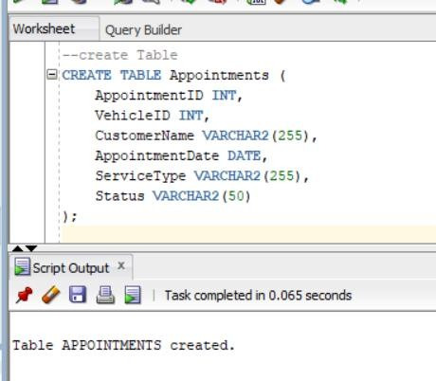

**Procedure for Add Appointments**

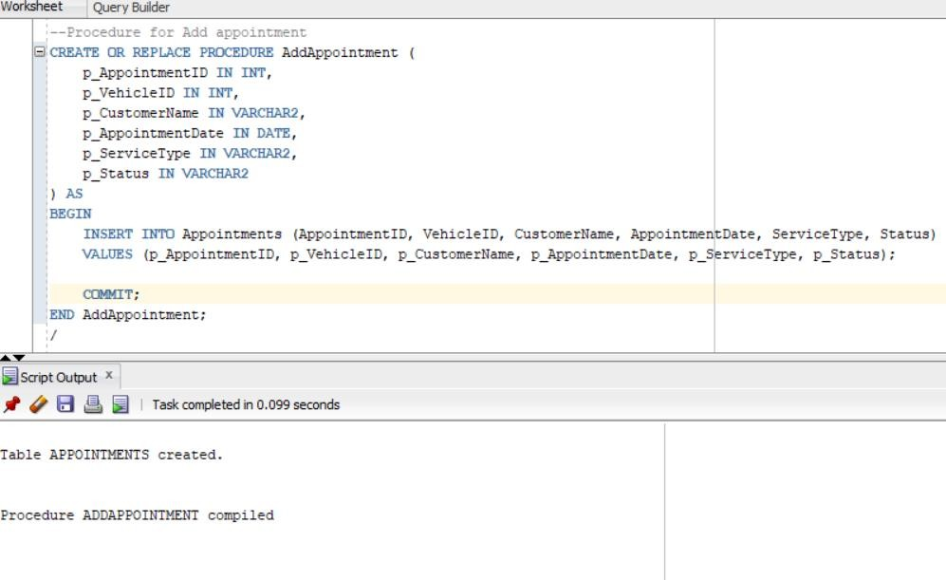

**Call the procedure**

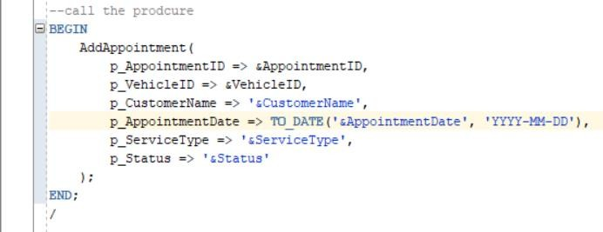

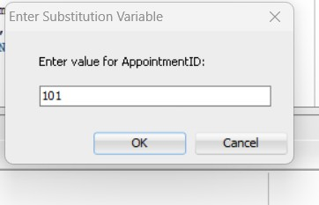

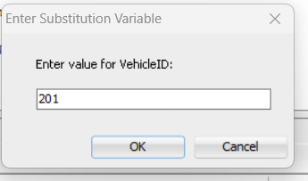

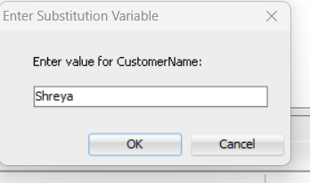

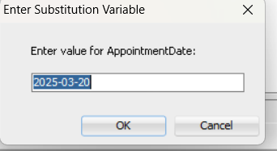

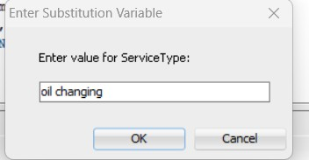

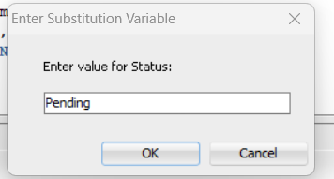

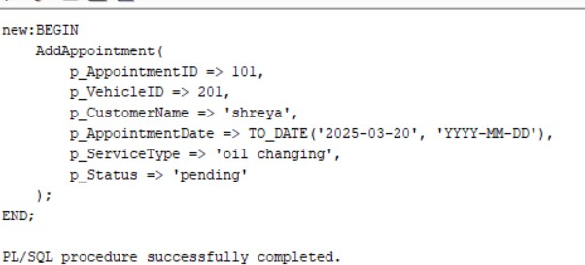

**Read appointments**

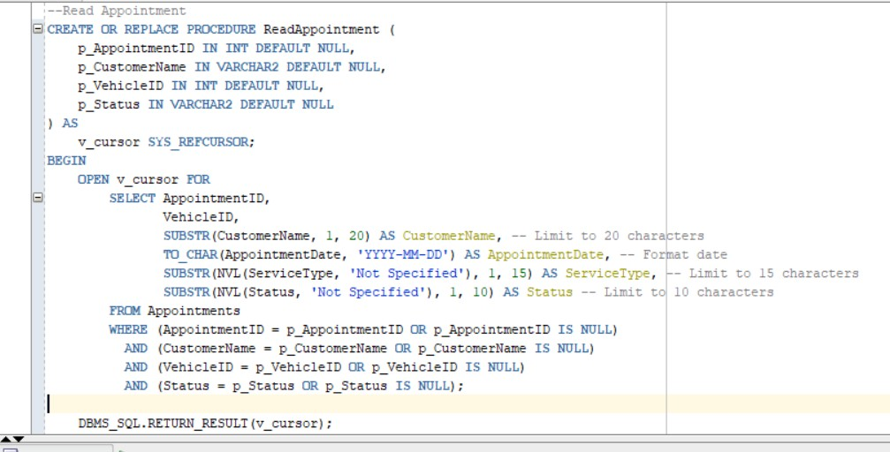

**Call the procedure**

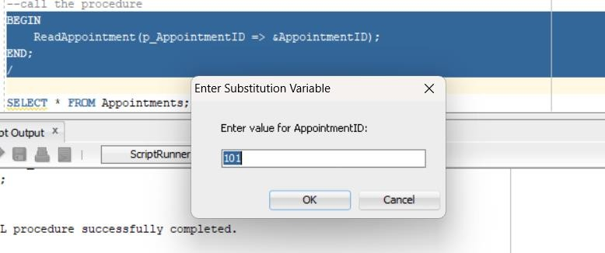

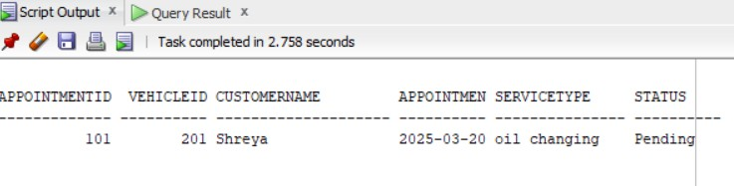

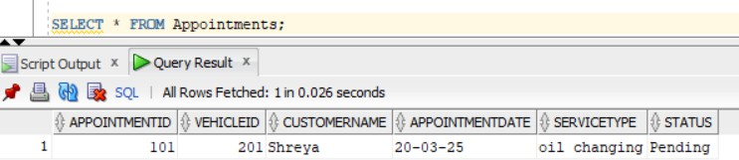

**Create service table**

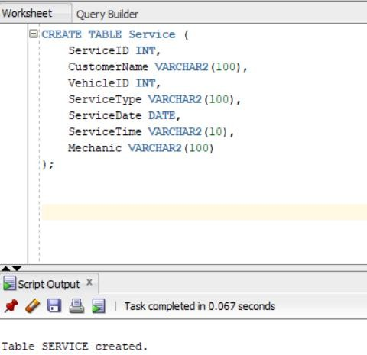

**Procedure to Add service**

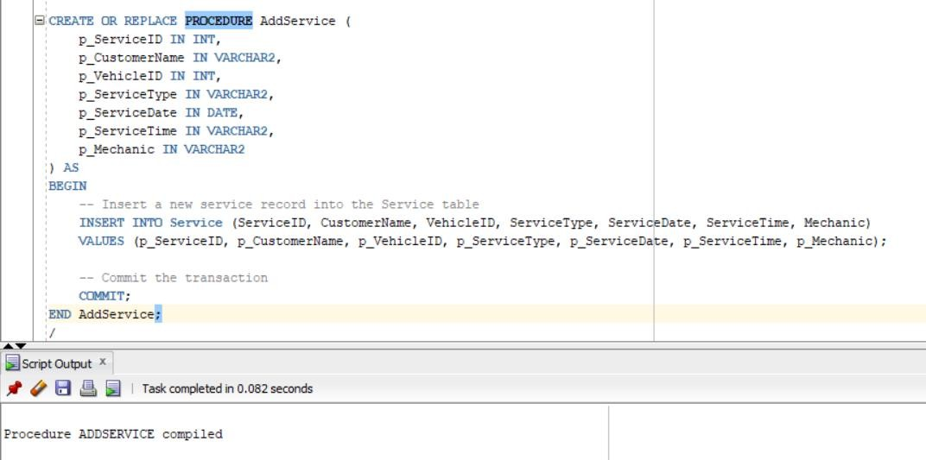

**Call the procedure**

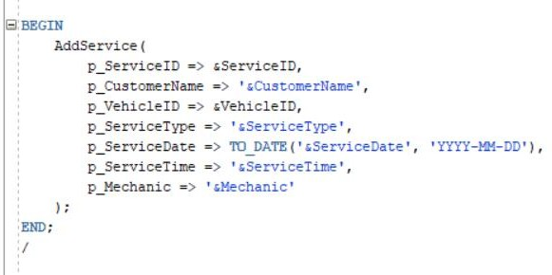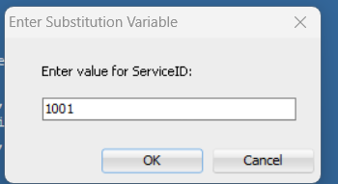

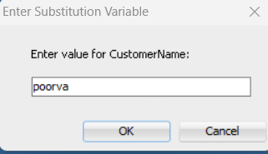

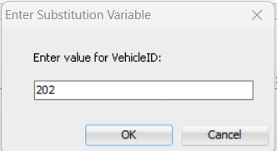

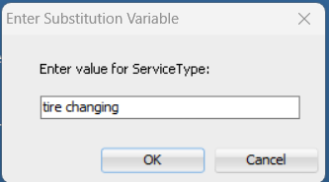

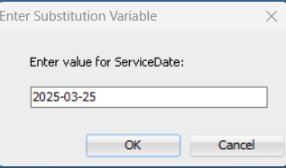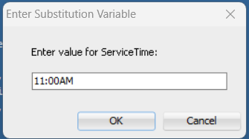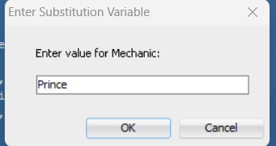

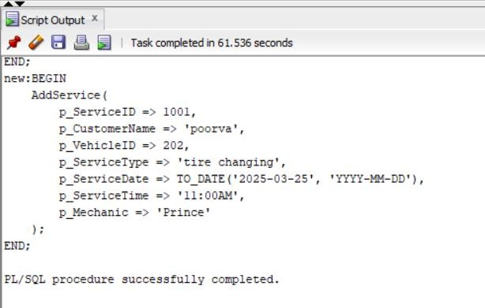

**Procedure for Read Service**

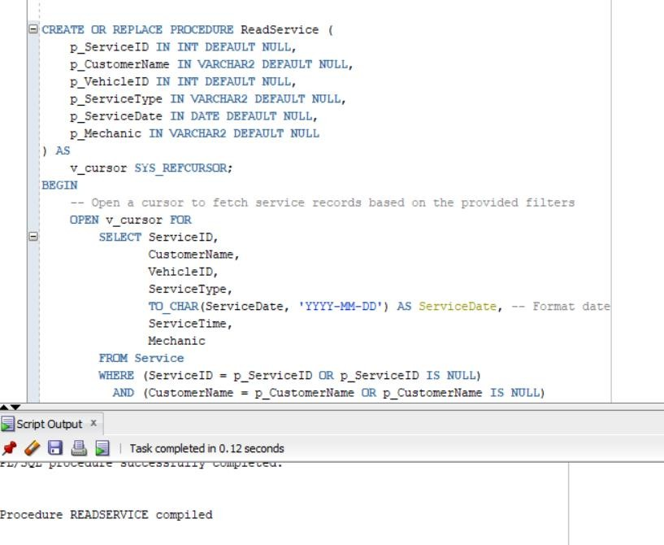

**Call the procedure**

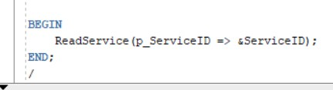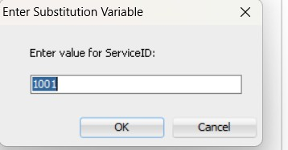

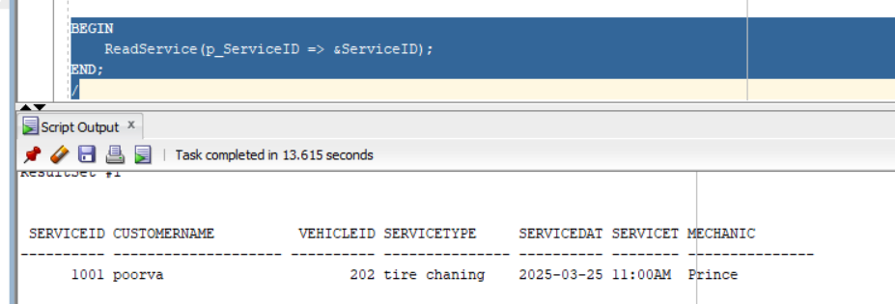

**Create function for fetching upcoming appointments**

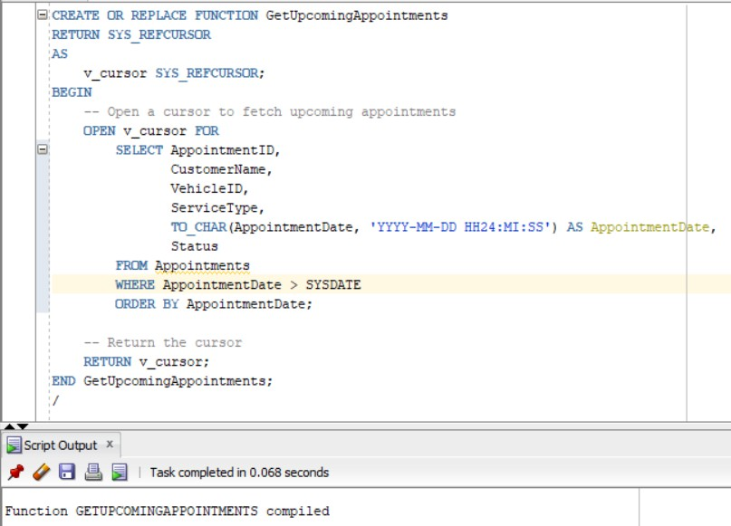

**Call the function**

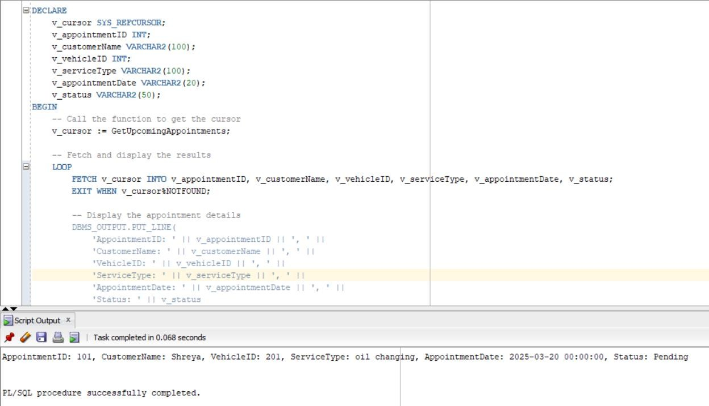

**Start Appointments UI**

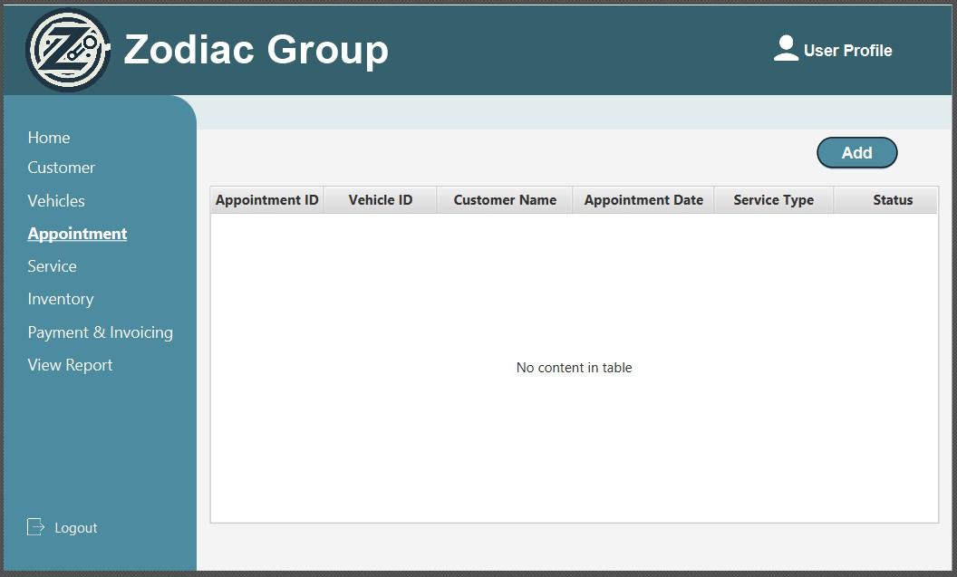

**When user click on ADD it will display the form to Add the details for booking the Appointment**

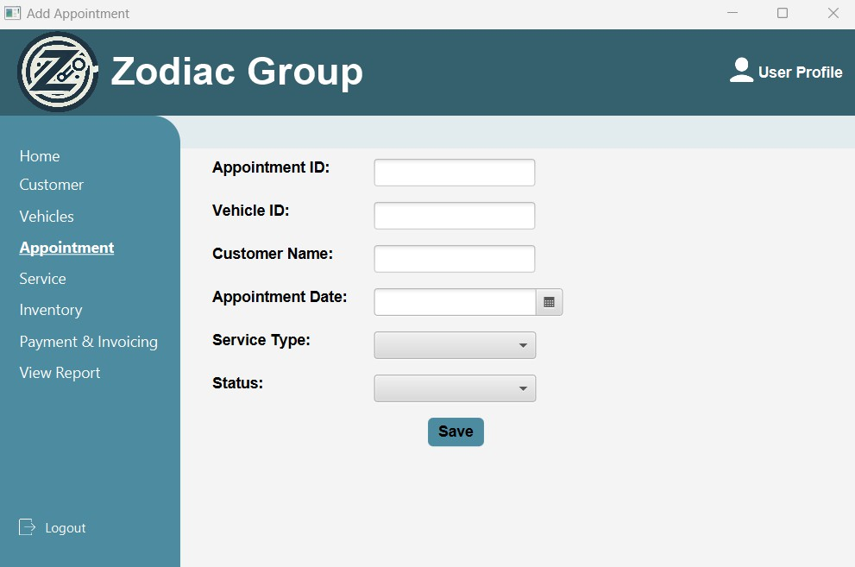

**Poorva**

**Create Customers Table** – This table stores customer details like name, email, phone, and address.

**Create Vehicles Table** – This table stores vehicle details and links each vehicle to a customer.

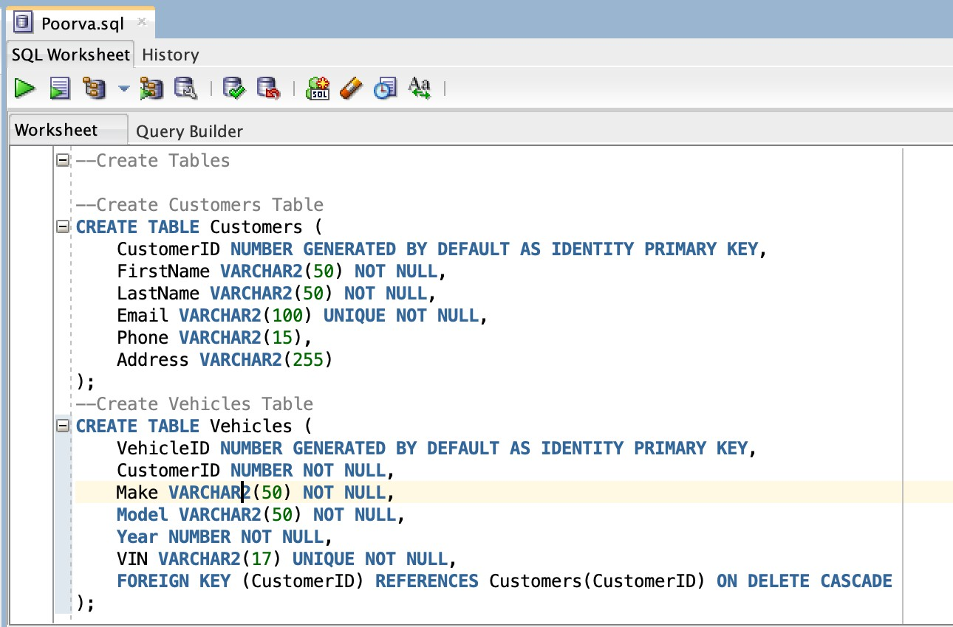

**Insert Customer Procedure** – This procedure adds a new customer to the database.

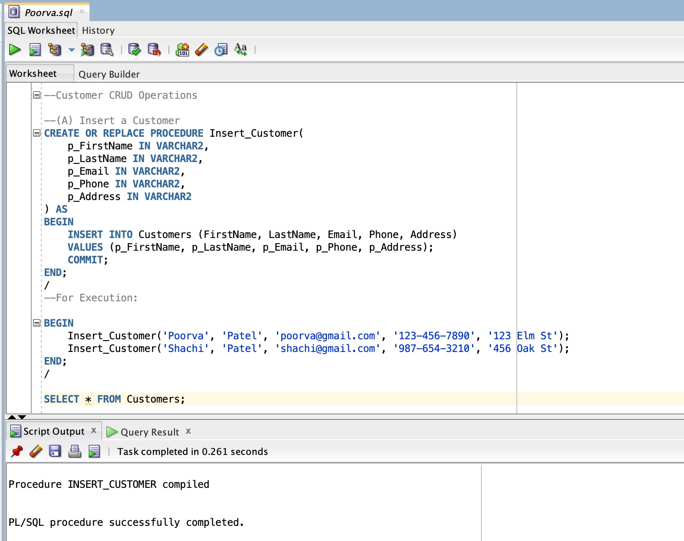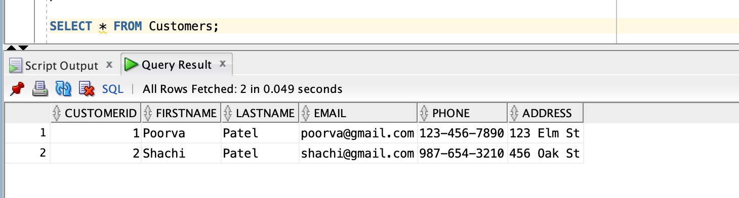

**Read Customer Procedure** – This procedure retrieves customer details using their ID.

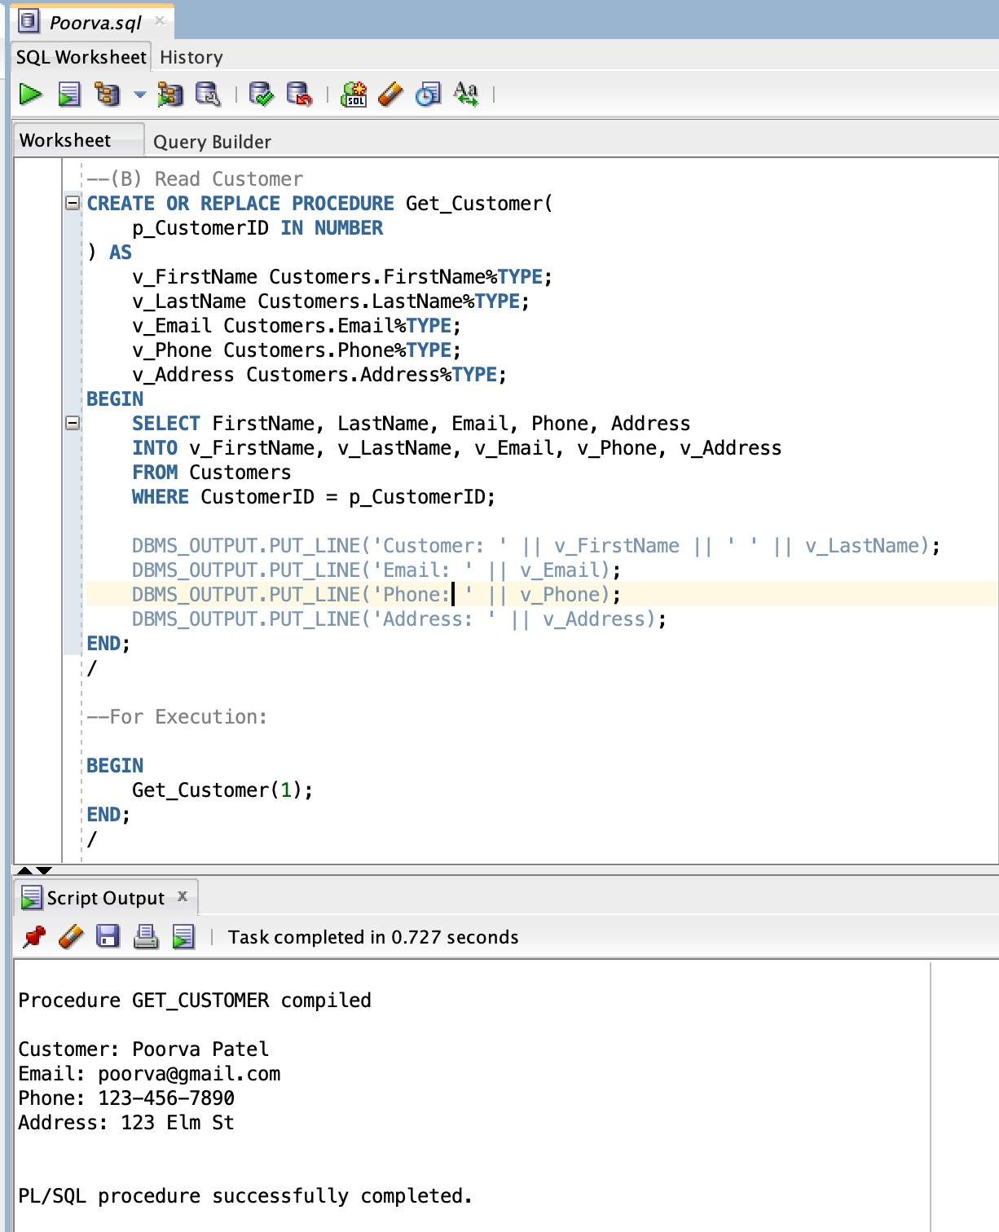

**Update Customer Procedure** – This procedure updates the details of an existing customer.

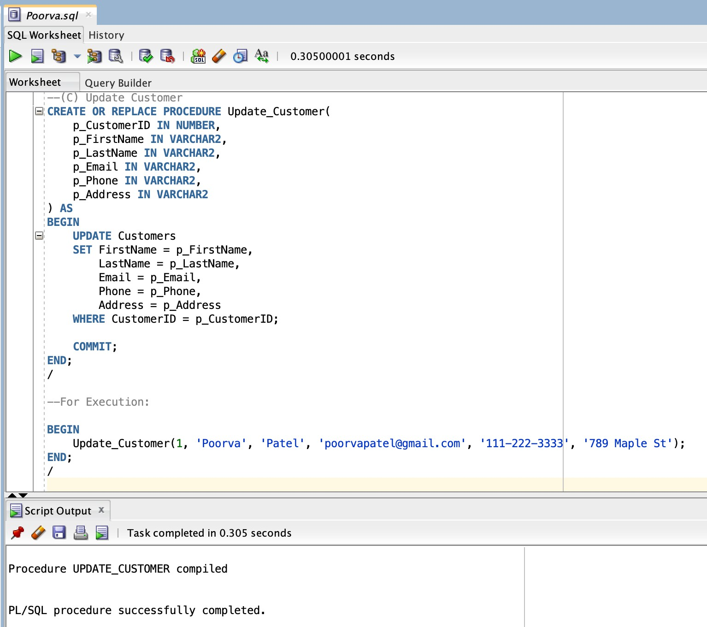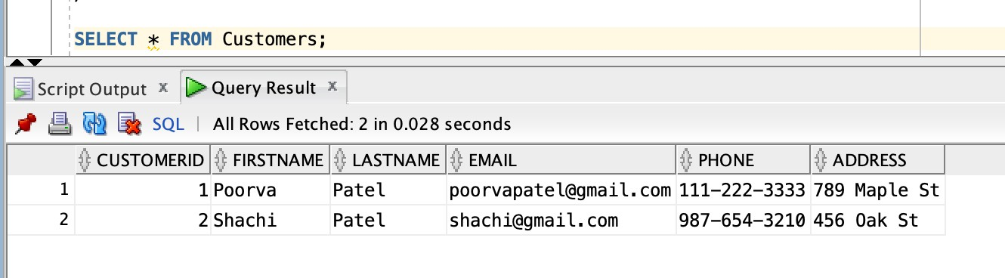

**Delete Customer Procedure** – This procedure removes a customer from the database.

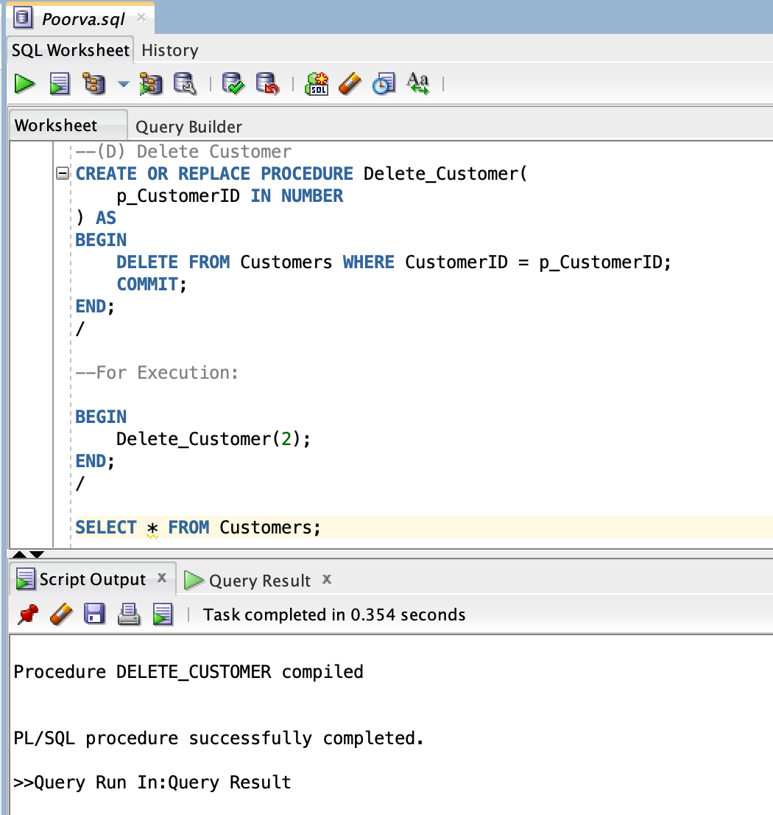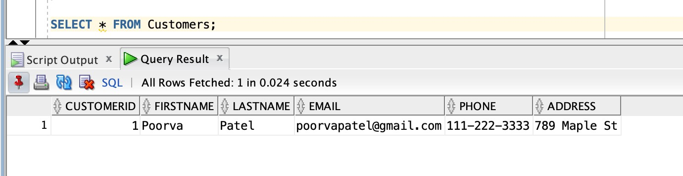

**Insert Vehicle Procedure** – This procedure adds a new vehicle for a customer.

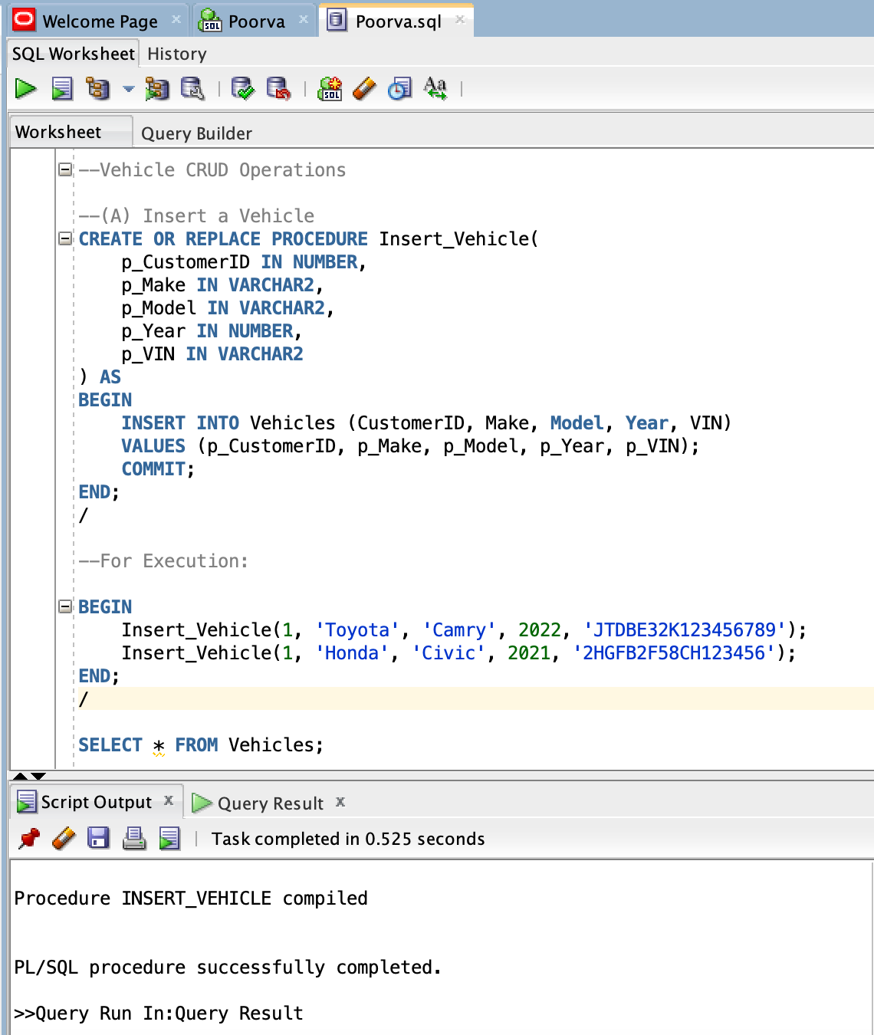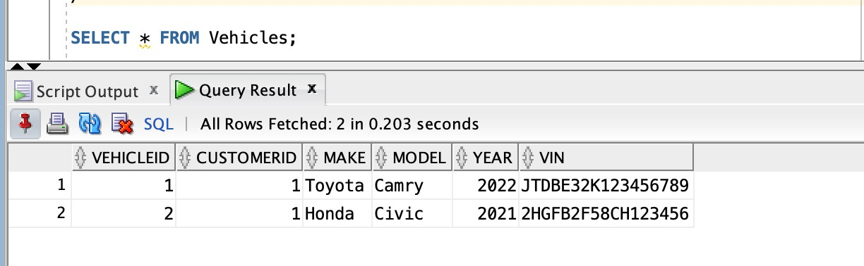

**Read Vehicle Procedure** – This procedure retrieves vehicle details using the vehicle ID.

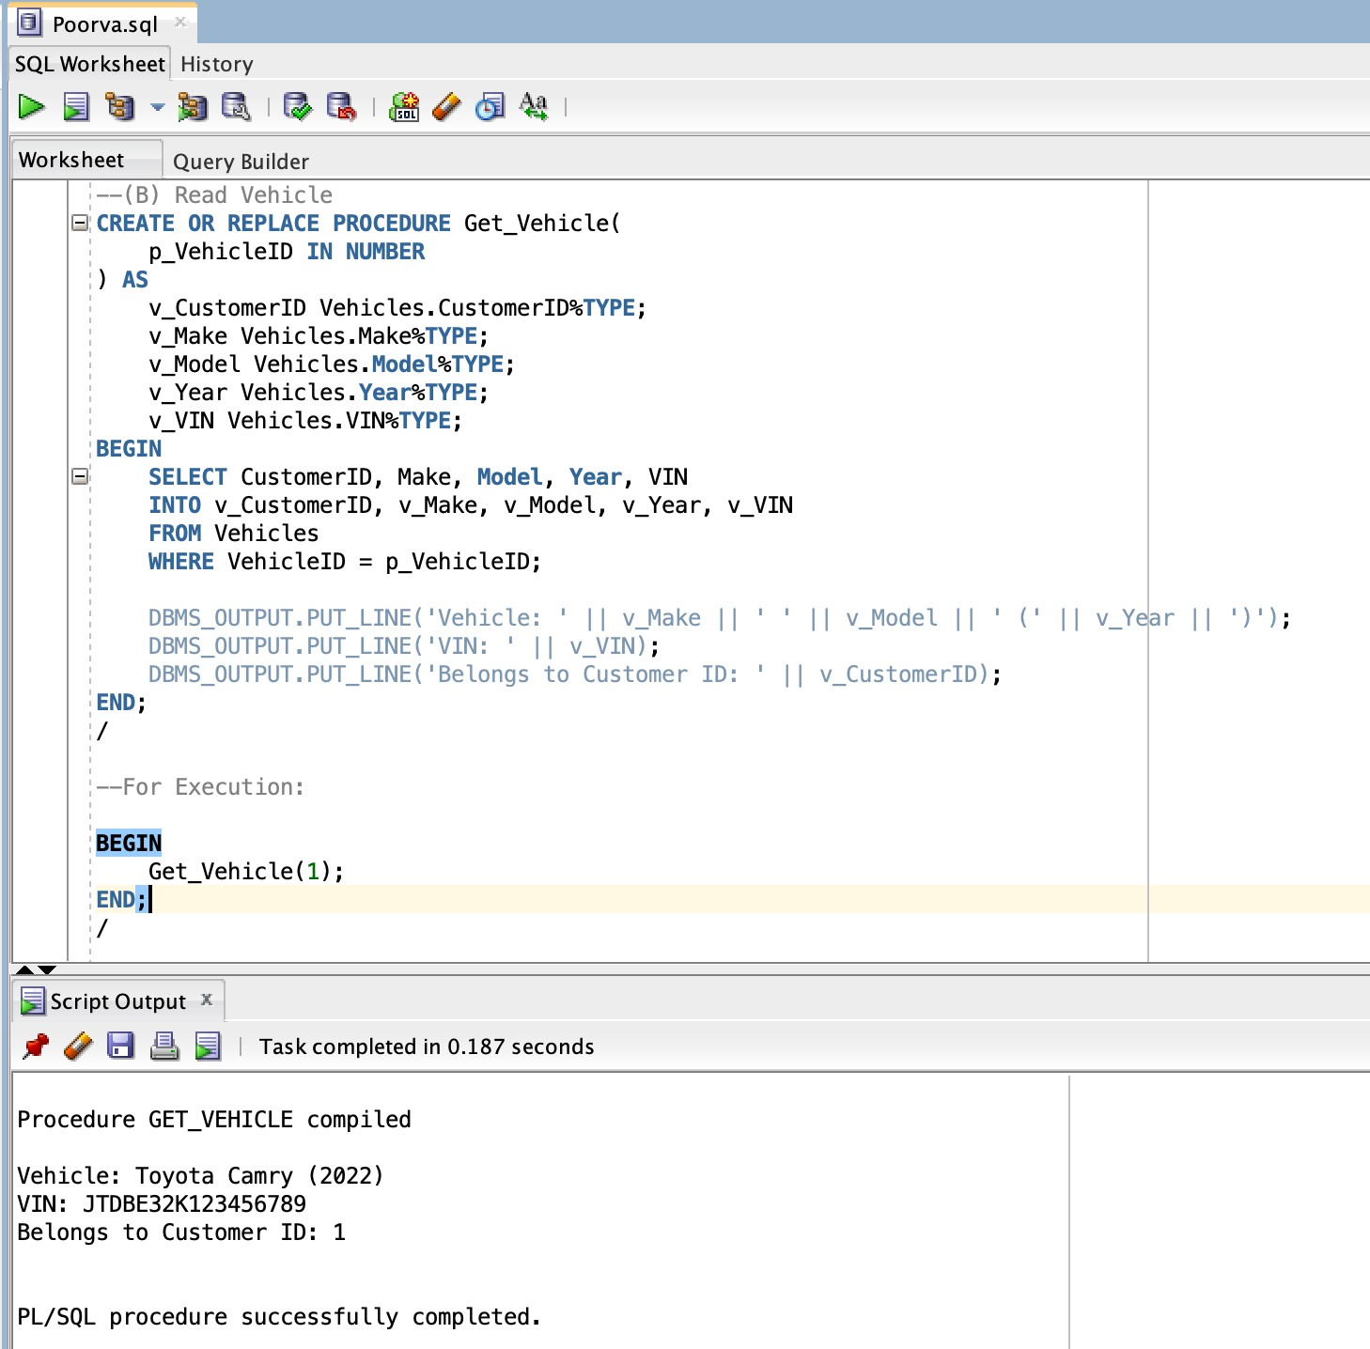

**Update Vehicle Procedure** – This procedure updates the details of an existing vehicle.

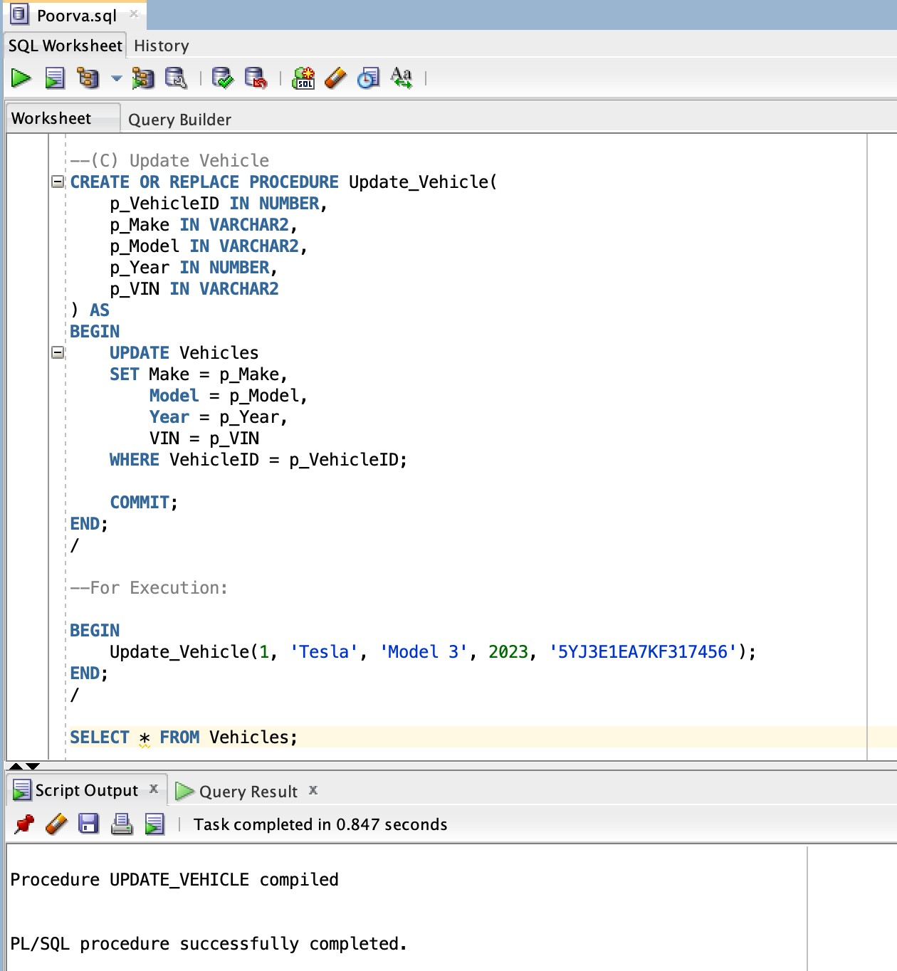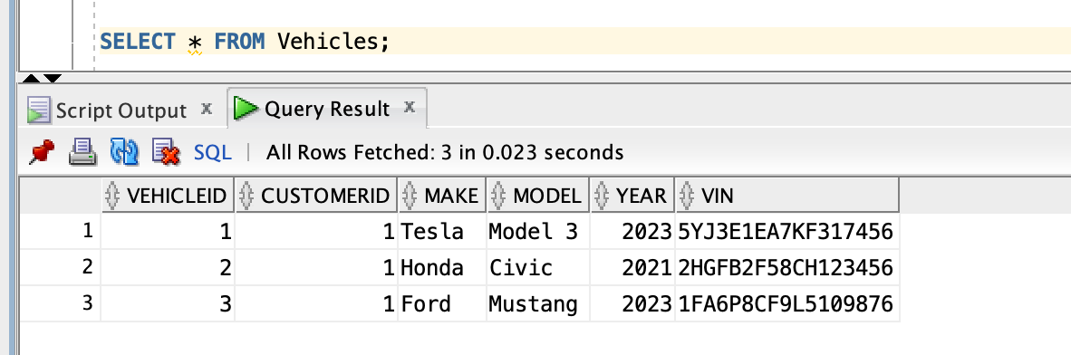

**Delete Vehicle Procedure** – This procedure removes a vehicle from the database.

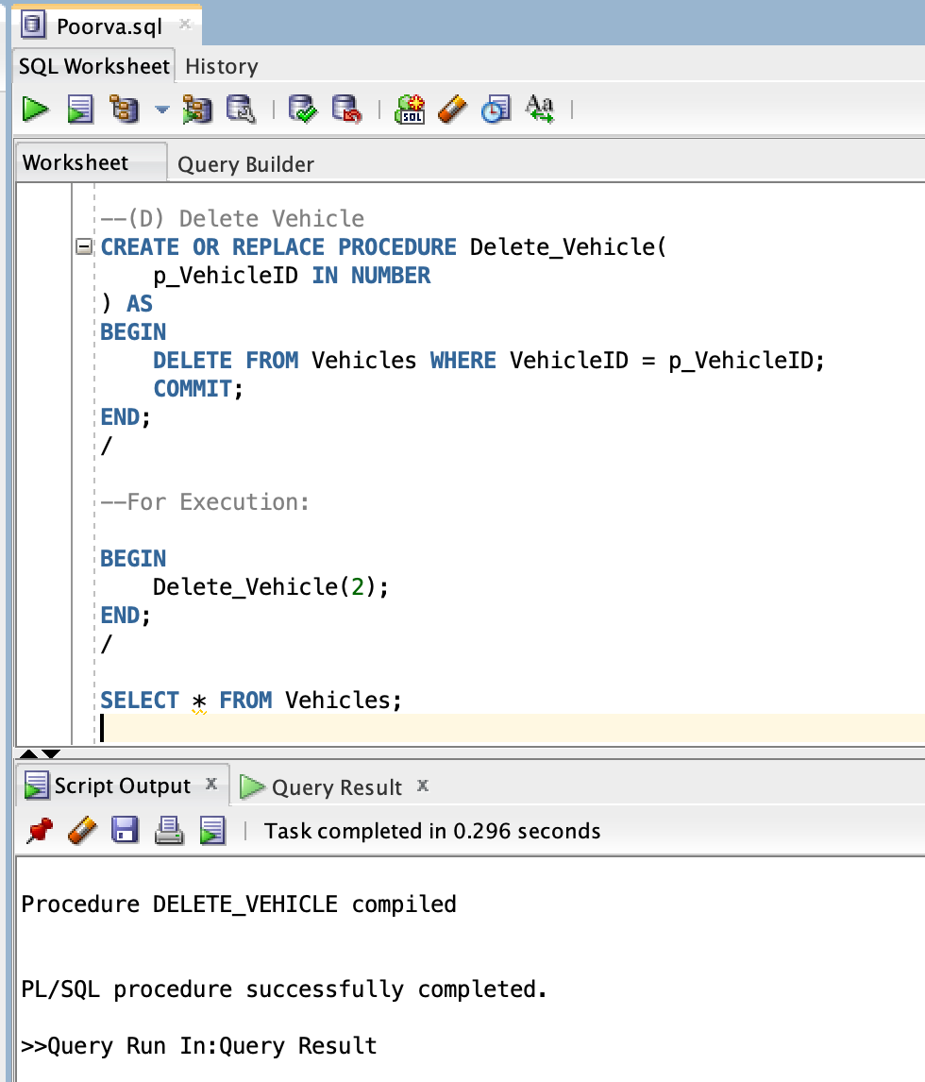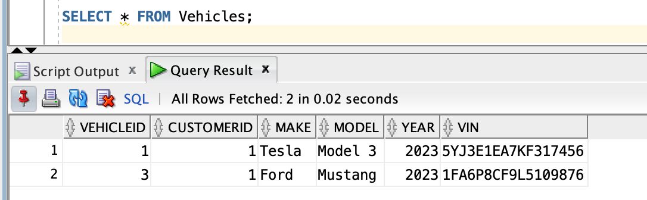

**Get Customer and All Vehicles Procedure** – This procedure retrieves a customer’s details along with all their vehicles using a cursor.

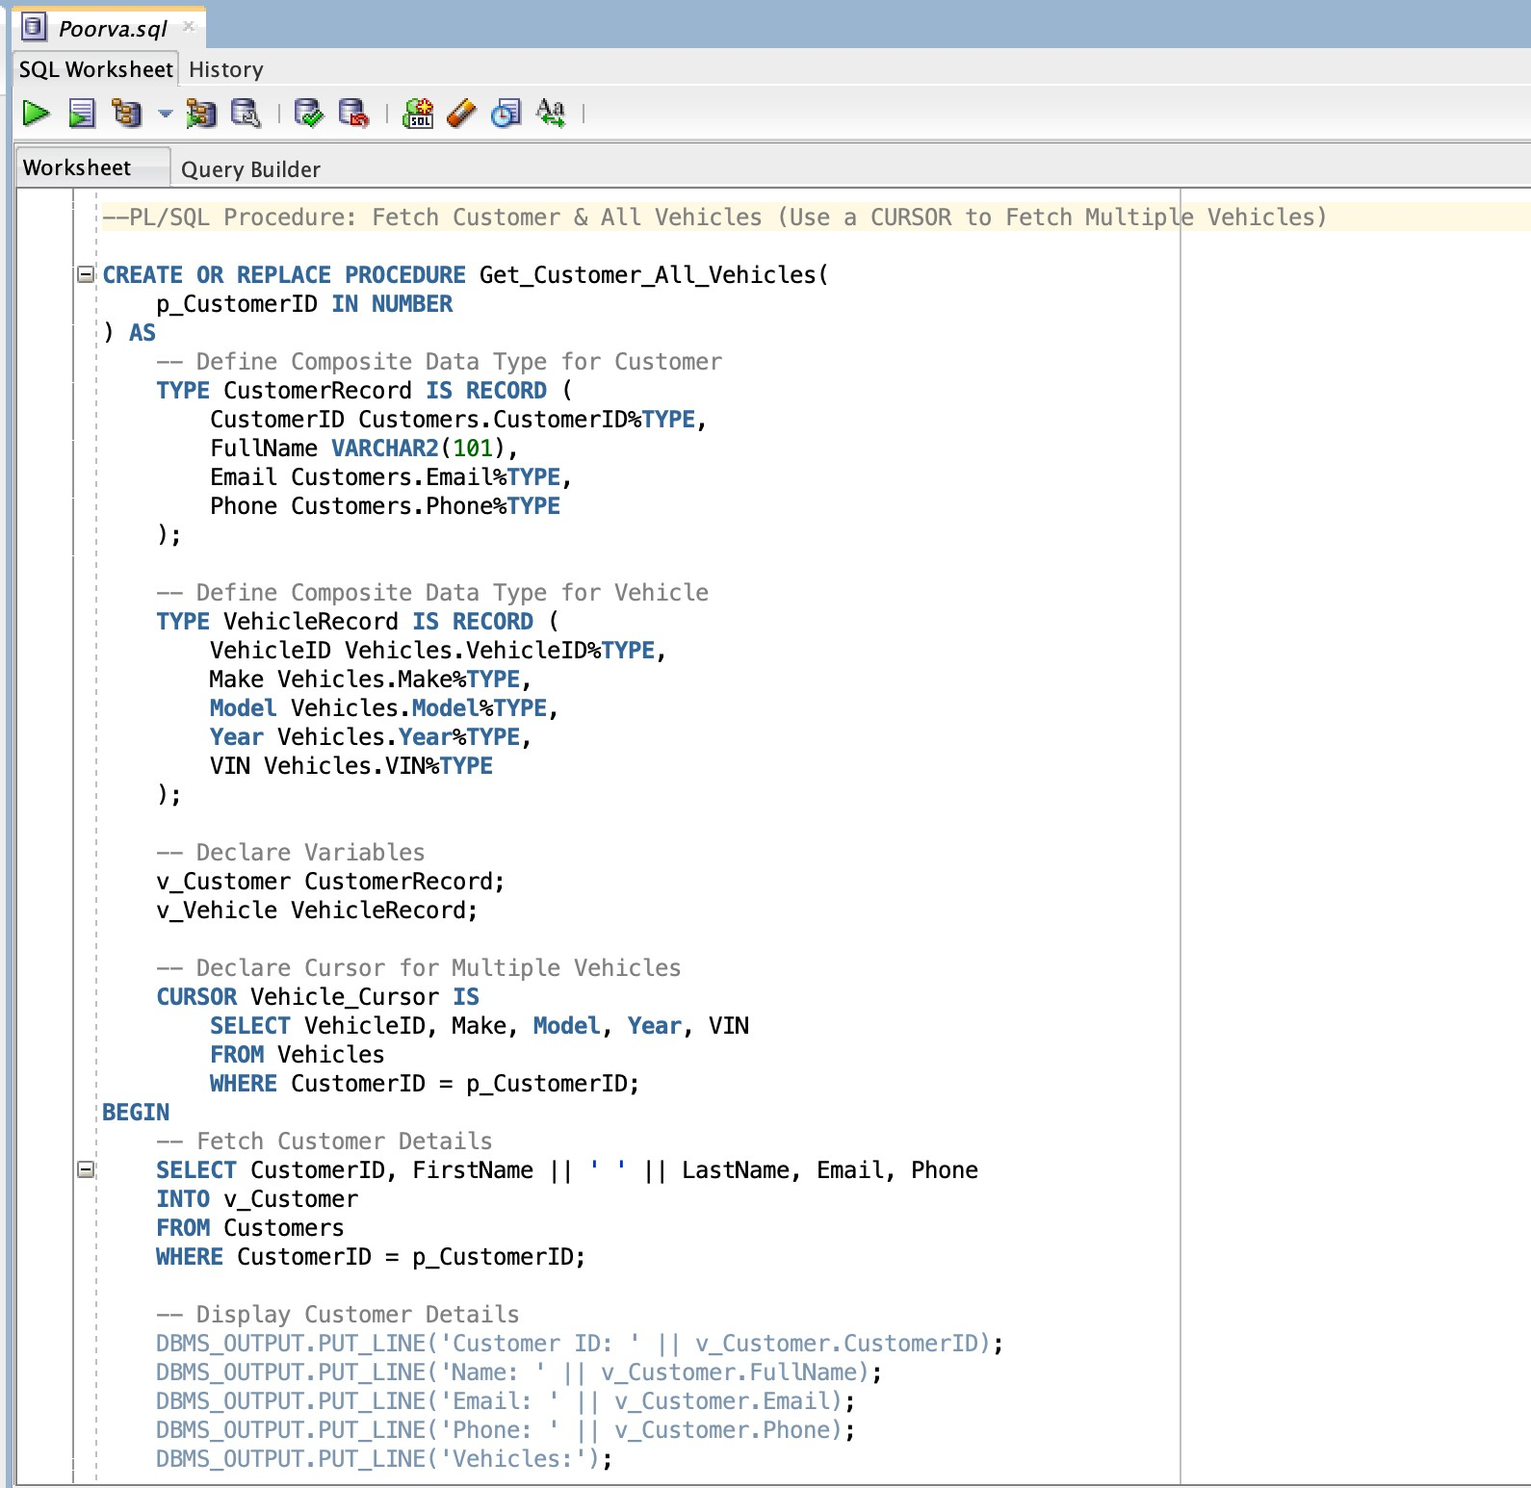

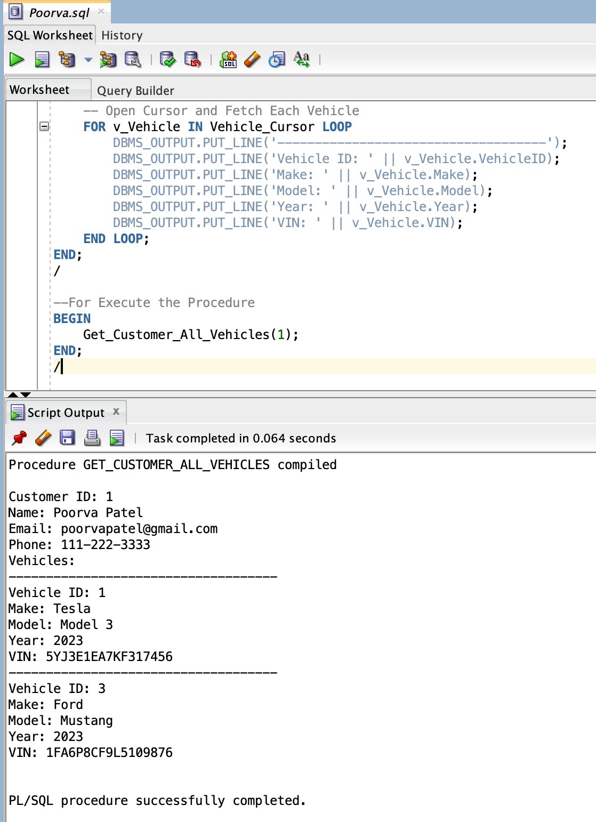

**Home Page UI**

This is the homepage UI, designed using a TabPane, which includes three tabs:

1. **Upcoming Appointments Tab** – Displays a list of upcoming customer appointments with details like vehicle, service type, date, time, and assigned mechanic.

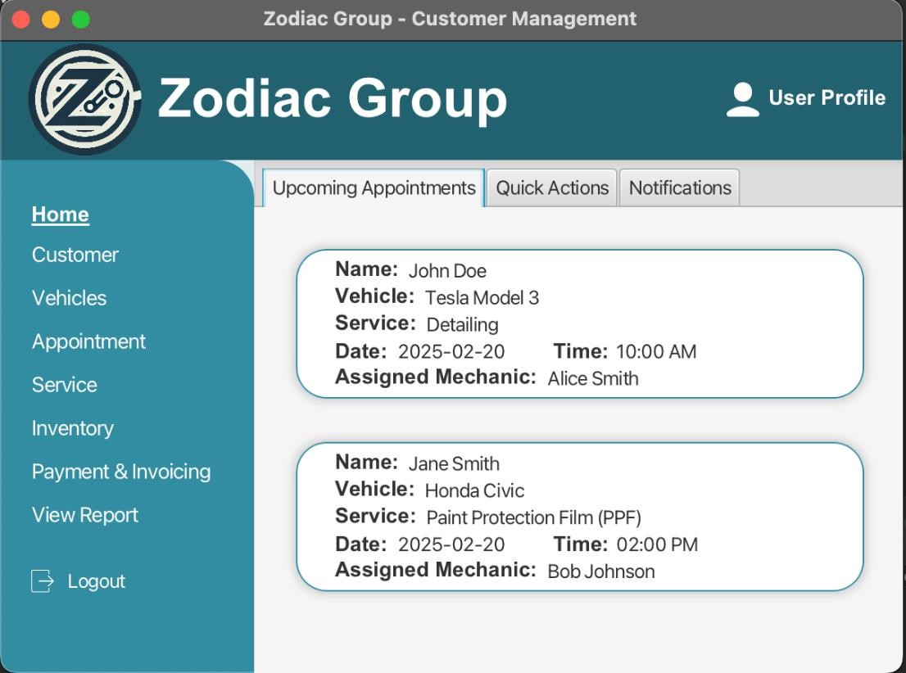

1. **Quick Actions Tab** – Provides shortcut buttons for adding customers, scheduling services, generating invoices, assigning mechanics, and viewing reports.

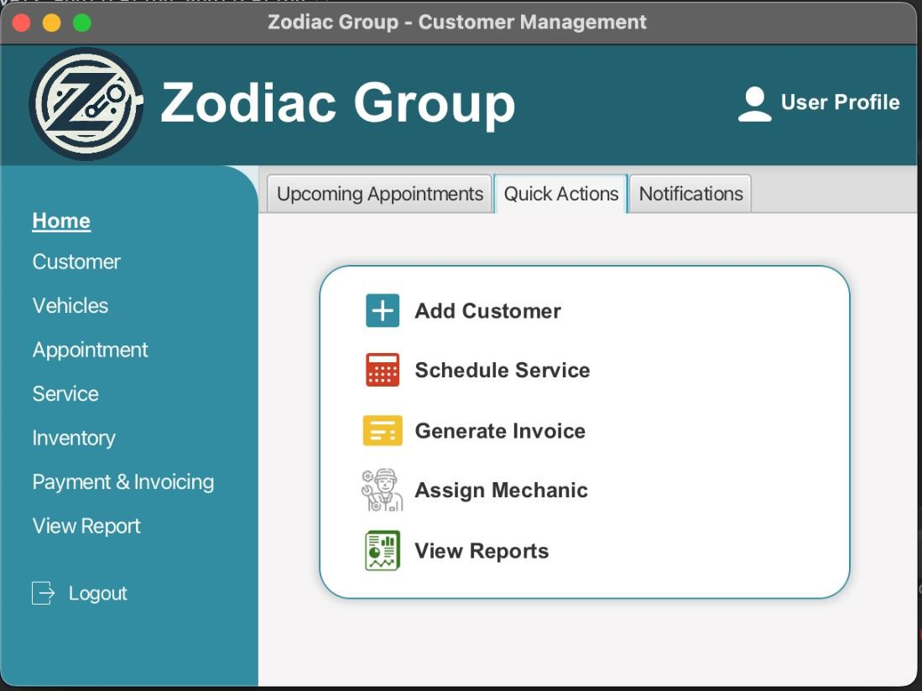

1. **Notifications Tab** – Shows important alerts, including low stock warnings, completed services, and overdue payments.

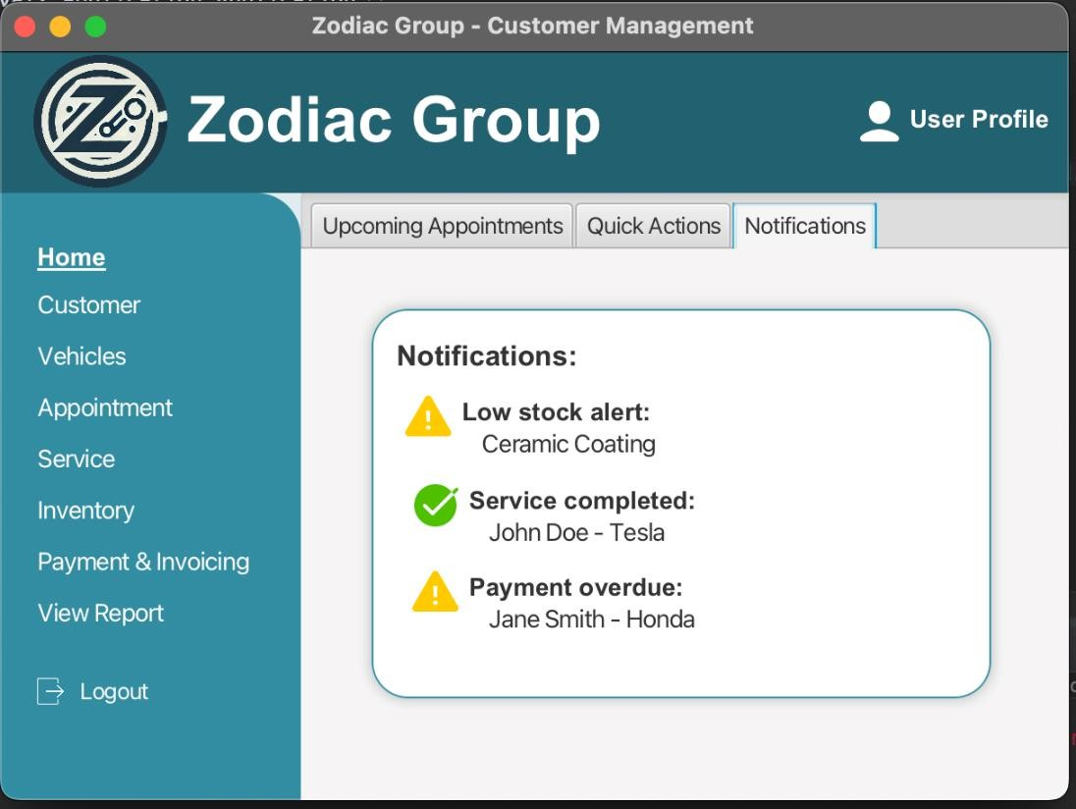

**Shirish**

**Create tables for Login and Mechanic**

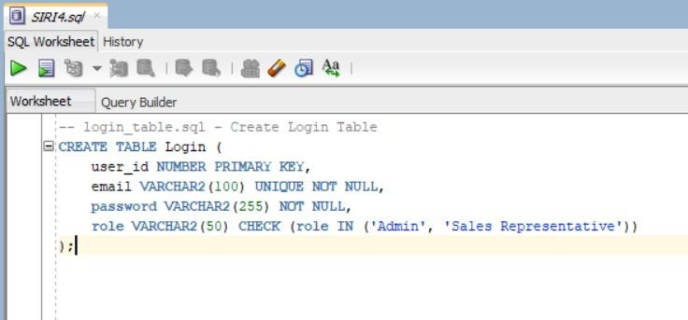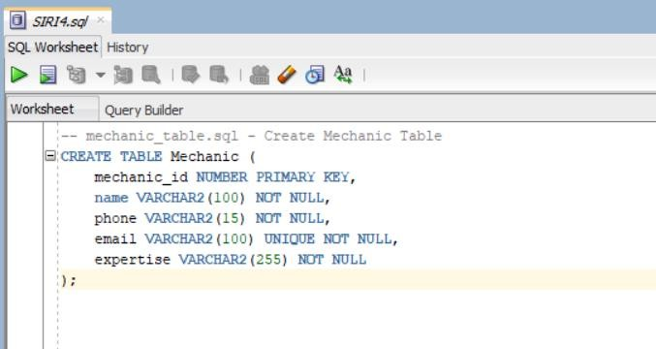

**Stored Procedures for login authentication**

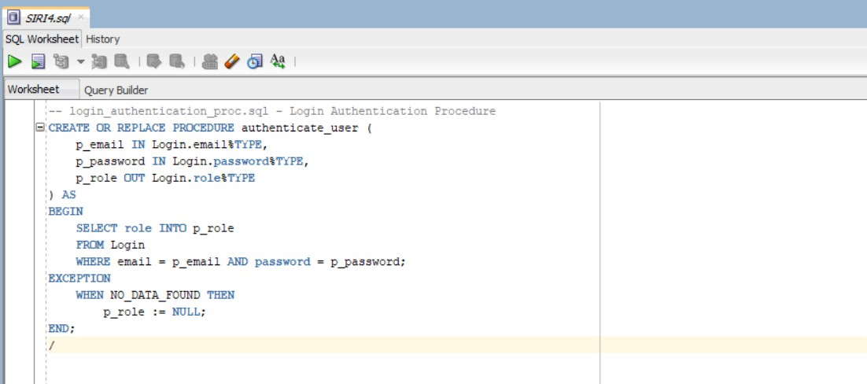

**Stored Procedures for Mechanic CRUD**

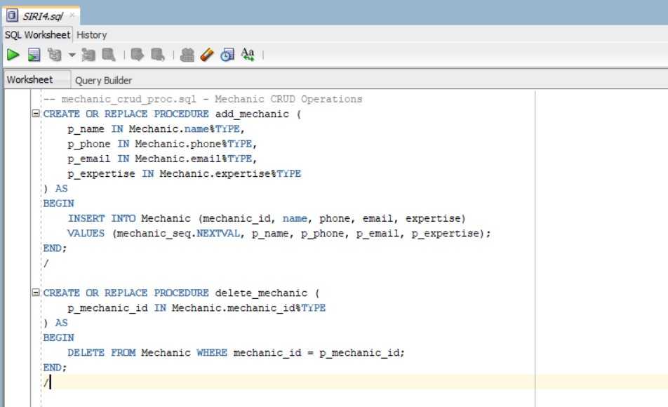

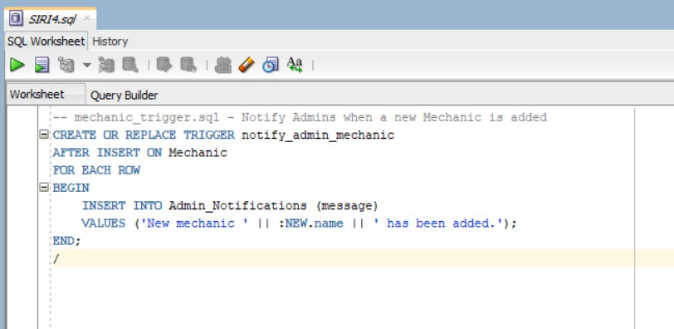

**JavaFX Login Page UI:** The JavaFX Login Page UI allows users to enter their email, password, and role (Admin/Sales Representative) and click the Login button. It then validates credentials and displays an alert indicating whether the login was successful or failed.

